To develop a page for emailing event date email, receiving confirmation of attending or not, and deleting the event from the receiver's end if not attending, you can follow these steps:

1. Set up a database: Create a database to store the event details, including the date, time, location, and other relevant information. You can use a SQL or NoSQL database to store the information.
2. Create a page: Develop a web page where the user can enter the details of the event and send an email invitation to the attendees. The page should have a form that allows the user to input the relevant event details, including the email addresses of the attendees.
3. Send email invitations: Use a server-side scripting language like PHP or Python to send email invitations to the attendees. The email should include the details of the event and a link to the confirmation page.
4. Confirmation page: Develop a confirmation page where the attendees can confirm their attendance or decline the invitation. The confirmation page should be linked in the email invitation.
5. Update the database: When an attendee confirms their attendance, update the database with their response. If they decline the invitation, remove the event from their calendar.
6. Delete the event: If the attendee declines the invitation, delete the event from their calendar. You can use a calendar API like Google Calendar or Microsoft Outlook to accomplish this.
7. Send confirmation email: Send a confirmation email to the attendee after they have confirmed their attendance. The email should thank them for accepting the invitation and include any additional details about the event.
8. Error handling: Implement error handling to handle any errors that may occur during the process, such as email delivery failures, database errors, or API errors.
9. Testing: Test the entire process to ensure that it works correctly and troubleshoot any issues that arise.

By following these steps, you can develop a page for emailing event date emails, receiving confirmation of attending or not, and deleting the event from the receiver's end if they are not attending.

i want it wit asp.net webforms c#

Sure, here's how you can develop a page for emailing event date email, receiving confirmation of attending or not, and deleting the event from the receiver's end if not attending using ASP.NET WebForms in C#:

1. Create a database: Set up a SQL Server database to store the event details, including the date, time, location, and other relevant information.
2. Create a WebForm: Develop a WebForm where the user can enter the details of the event and send an email invitation to the attendees. The WebForm should have a form that allows the user to input the relevant event details, including the email addresses of the attendees.
3. Send email invitations: Use the System.Net.Mail namespace in C# to send email invitations to the attendees. The email should include the details of the event and a link to the confirmation page.
4. Confirmation page: Develop a confirmation page where the attendees can confirm their attendance or decline the invitation. The confirmation page should be linked in the email invitation.
5. Update the database: When an attendee confirms their attendance, update the database with their response. If they decline the invitation, remove the event from their calendar.
6. Delete the event: If the attendee declines the invitation, delete the event from their calendar. You can use a calendar API like Google Calendar or Microsoft Outlook to accomplish this.
7. Send confirmation email: Send a confirmation email to the attendee after they have confirmed their attendance. The email should thank them for accepting the invitation and include any additional details about the event.
8. Error handling: Implement error handling to handle any errors that may occur during the process, such as email delivery failures, database errors, or API errors.
9. Testing: Test the entire process to ensure that it works correctly and troubleshoot any issues that arise.

By following these steps, you can develop a page for emailing event date emails, receiving confirmation of attending or not, and deleting the event from the receiver's end if they are not attending using ASP.NET WebForms in C#.

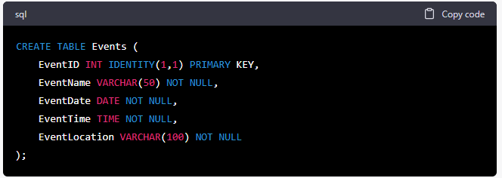

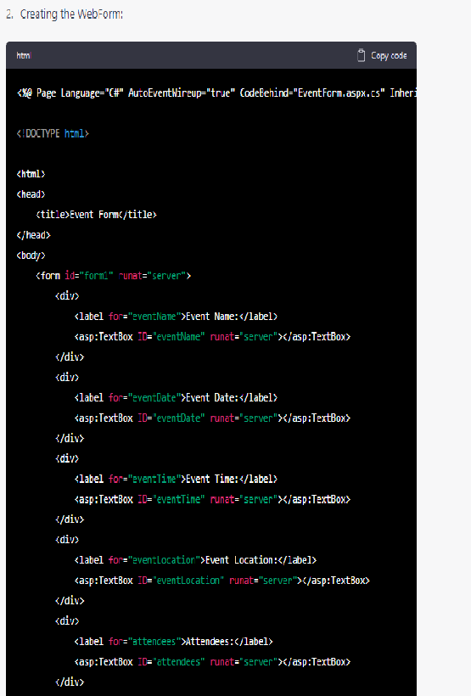

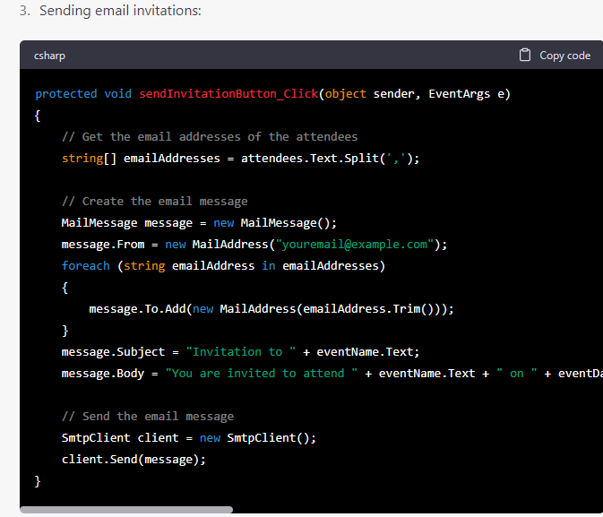

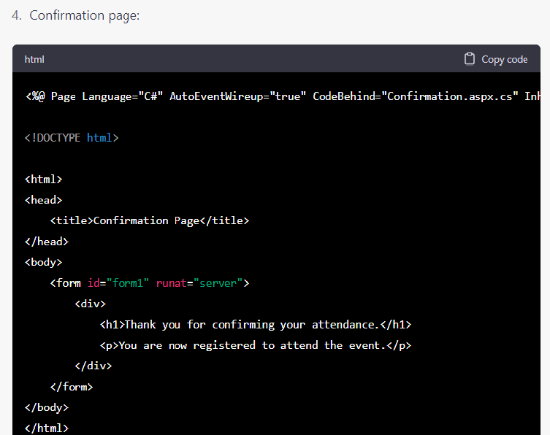

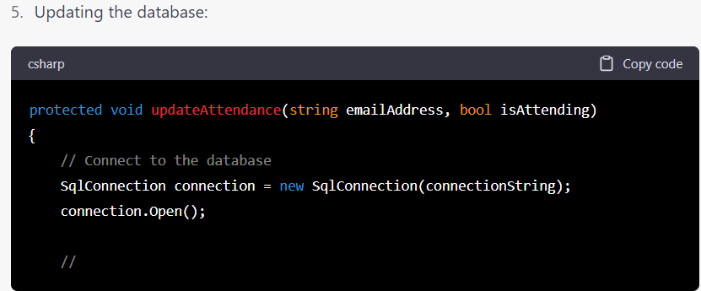

for asp:text boxes above do i need to give ID or clientid?

In ASP.NET WebForms, you should use the **ID** property to identify server-side controls such as **asp:TextBox**. The **ID** property is used to generate the **ClientID** property, which is used on the client-side to identify the control when using JavaScript.

When you set the **ID** property of a server-side control, it is automatically assigned a unique **ClientID** value, which is used to generate the HTML **id** attribute of the control. This ensures that the control can be accessed by JavaScript and other client-side code.

So, in the sample code provided, you should use the **ID** property to identify the text boxes, for example:

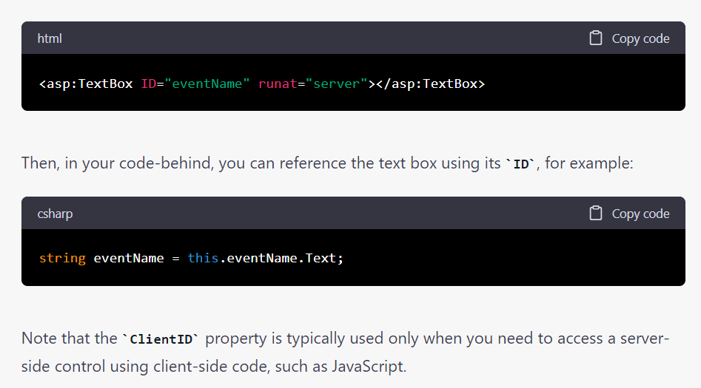

HOW WILL ABOVE CODE DELETE DECLINED REQUEST IN SEVEN DAYS

To automatically delete declined event requests after seven days, you will need to implement a background process or task that periodically checks the database for declined events that are older than seven days and deletes them.

One way to implement this is to use a Windows service or a console application that runs periodically using a scheduler, such as the Windows Task Scheduler. The application can connect to the database, query for declined events that are older than seven days, and delete them.

Here's an example of how you could implement this in C#:

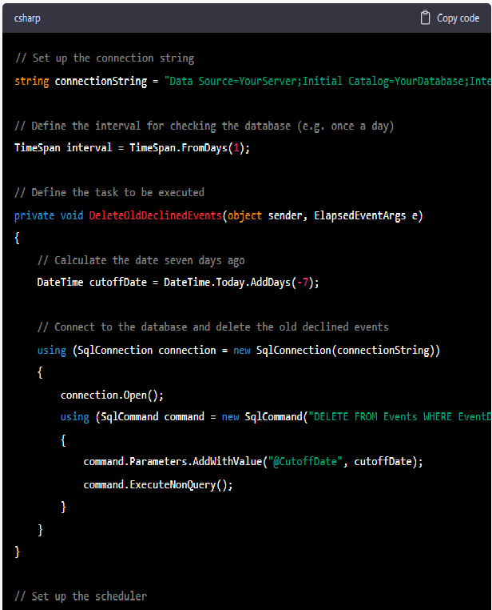

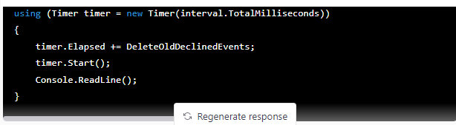

This code defines a method called **DeleteOldDeclinedEvents** that is executed periodically using a timer. The method connects to the database and deletes any events that are older than seven days and have been declined. The timer is set up to execute the method once a day.

Note that this code is just an example and may need to be modified to fit your specific needs. For example, you may need to adjust the interval or the SQL query to fit your database schema. Additionally, you may want to add error handling and logging to handle any exceptions that may occur during the process.